Address of Sojourner Truth (1867)
Well, things that past a good while, there's no use over-calling them again. Old things is passed away, and all things are become new, (Applause and laughter.) I was sitting and looking around here--I've been to a great many conventions, a great many meetin's in the course
of my life-time -- in eighty years, and I've heard a great many speeches, but I've heard a great many answers in the anti-slavery meetin's. A half dozen would pop up, some pop up here, some there. But in this meetin' there has been nobody to pop up. (Laughter and applause.) Nobody to gainsay.
I havn't seen any one grumblin'. I never heard a meetin' before but there was great grumblin' and mutterin' goin' on. (Laughter.) Now, I say we are gainin' ground. Haven't you noticed; here is antislavery women--a great many kinds; and did you ever behold a meetin' and see so many people together--both male and female; the body of the church full; and every one's countenance looks pleasin', looks pleasant. (Laughter.) It seems to me it's all coming right. Every one feels it's right and good. Why, I've been in meetin's and heard men gabble, gabble, gabble; but now it seems to me all pleasant. Why, this war has done a great deal of good, besides doing a great deal of harm. (Laughter.) People seem to feel more for one another. Certainly I never saw so many people together and nobody tryin' to hurt anybody's feelin's. (Applause and laughter.) I guess there's those here that's been to meetin's and heard it. Women has been here talkin', and throwin' out arrows--there was nobody gettin' mad, or if they was they didn't let us know it. (Laughter.)
Well, Sojourner has lived on through all the scenes that have taken place these forty years in the anti-slavery cause, and I have plead with all the force I had that the day might come that the colored people might own their soul and body. Well, the day has come, although it came through blood. It makes no difference how it came--it did come. (Applause.) I am sorry it came in that way. We are now trying for liberty that requires no blood--that women shall have their rights -- not rights from you. Give them what belongs to them; they ask it kindly too. (Laughter.) I ask it kindly.
Now, I want it done very quick. It can be done in a few years. How good it would be. I would like to go up to the polls myself. (Laughter.) I own a little house in Battle Creek, Michigan. Well, every year I got a tax to pay. Taxes, you see, be taxes. Well, a road tax sounds large. Road tax, school tax, and all these things.
Well, there was women there had a house as well as I. They taxed them to build a road, and they went on the road and worked. It took 'em a good while to get a stamp up. (Laughter.) Now, that shows that women can work. If they can dig up stumps they can vote. (Laughter) It is easier to vote than dig stumps. (Laughter.) It doesn't hard work to vote, though I have been some men that had a hard of it. (Laughter.) But I believe that when women can vote be so many men that have a rough time gettin' to the polls. . There is danger of their life sometimes, I guess in this city. are in this city. I don't want to take up time.
I calculate to live. Now if you want me to get out of the world, you had better get the women votin' soon. (Laughter.) I shan't go 'till I can do that. I think it will come along pretty soon. (Laughter.) Now I think I will sing a little bit. I sung the other night, and my singin' -- well, they can't put things down on paper as we speak, though I speak in an unknown tongue. (Laughter.) Now, what I sing they ain't got it in the right way--not in the way I meant it. I am king of poet -- what do you call it that makes poetry? I can't read it, but I can make it. You see I have sung in the anti-slavery meetin's and in the religious meetin's. We, they didn't call anti-slavery religious, and so I didn't call my song an anti-slavery song--called it religious, so I could make it answer for both. (Great laughter.) Now I want the editors to put it down right. I heard it read from the 'paper, but it don't sound as if they had it right. Sojourner then sang her song.

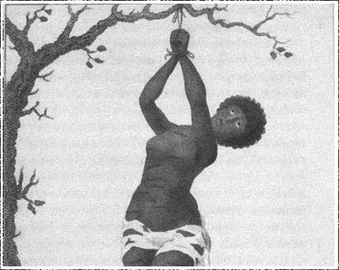
1. What details do you notice about this photo?
2. What do you think is happening in this photo?

3. What might be the significance/ importance of what is happening in this photo?

http://www.pbs.org/show/slavery-another-name/

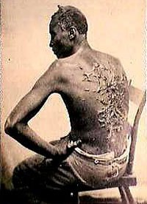
1. What details do you notice about this photo?
2. What do you think is happening in this photo?

3. What might be the significance/ importance of what is happening in this photo?

